**!!Please note that this section is currently under development!! Not Official as of yet, or is it?**

**Dragonscale Island**

Long ago, there once was a…

Located within the Sea of Serpents (towards the south of The Land of Spira) lies Dragonscale Island ruled by beasts and lords alike.

It has been said that the mightiest of dragons and lizardkin dwell here aside from those that have moved inland. It is said that one lord known as The Dragon King rules above all that serve him loyally with the utmost fealty.

Merge home of the dragon king. I will add this from my notes along with this.

-Dragons are naturally able to shapeshift and scale up or down, aquatic dragons are amorphous and suddenly and silently strike so the only sound that can be heard is the crashing of waves and crushing of wood, steel, and bones.

Once Dracus (The Dragon King) is defeated and his soul freed, you get a key and learn the true villain's identity. You along with an army, possibly, or Divine intervention from the guardians of Spira or herself help you out to slay the dragon, mightier than a certain enemy that slew Felius and his party once.

players would have to face one of many trials represented by each element type and guardian. Each area will be represented by each element.

The Dark Serpent Of The Ravine

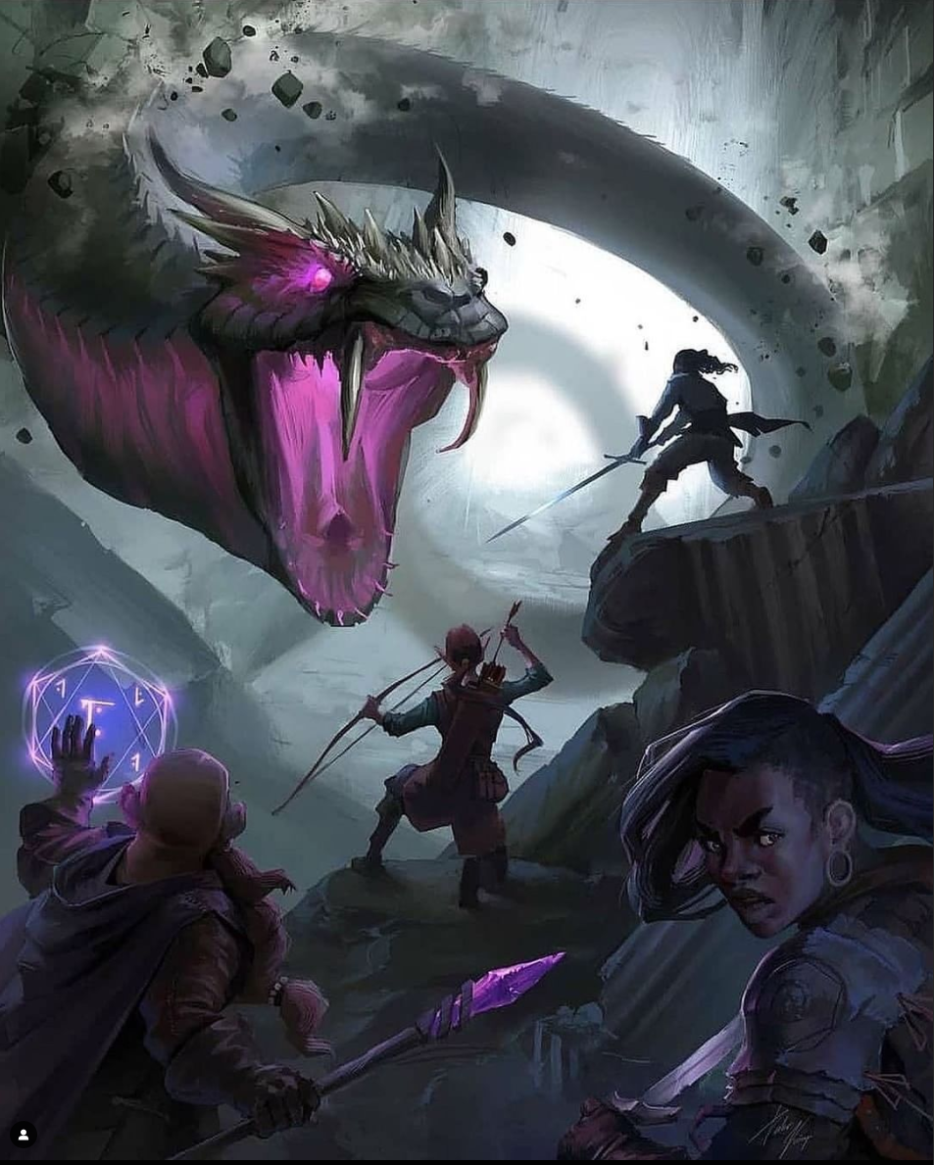

Dracus. Dragonscale.

Expansion name: Scales, Serpentine,

Island name: Dragonscale Island

Location:

Towns and Areas:

Dragonscale Summit

Dragonscale Dungeon

Dragonscale Vale (Valley)  
  
Dragonscale Grotto (Cave)

Serpentscale Village - Part of Jormungandr’s head

Lava Lizard Lake

Different areas with elemental themes and cross between the like: fire, ice, etc.

Dragons, Serpents, Lizards, Wyrms, Wyverns, will become neutral and allied to you and once the Skylands is free from a foe, use the dragon horn to call an army of all dragons, snakes, and lizards alike to defeat a dark dragon.

Dracus Dragonscale will become a benign lord of all dragons and lizards alike and when the time comes, call for their aid against the true villain in the final fight for all of Spira, all enemies and heroes under a united alliance to save their world from utter destruction.

Quest rewards:

Dragonsword: double elemental damage for weapons, for spells, or double accuracy

Celestial damage

Dragonshield:

Immune to all elements and natural attacks and effects, or double defense

Dragonpriest armor and robes